
_____________________________________________________________________________________

Council Rock Holland Baseball Organization

2025

Safety Manual

Contents
Organization 3
Distribution 3
Key official’s phone and emergency numbers 3
Field Locations 3
Background Checks 3
Training 4
Coaching 4
First-Aid, AED & CPR 4
CDC Concussion Training 4
Facilities & Equipment 4
Activities 5
Pitch Counts 5
Concession Stand & Food Handling Tips 6
12 Step Safety Outline 6
Clean Hands for Clean Food 7
Top Six Causes that Lead to Illness 8
League Officials Contact Information: 9
Appendix 1 – St. Leonards Road – Complex Map 10
Appendix 2 – Big Meadow – Complex Map 11
Appendix 3 – Injury Report Form 12
Appendix 4 – Medical Release Form 13

Organization
Council Rock Holland Baseball Organization (CRHBO) has designated its Safety Officer, Brian Susten, who is also a board member. The current Safety Officer is registered with Little League International.
This document serves as the League’s Safety Policies and Manual. Items in bold are new to the document.

Distribution
A hardcopy will be provided to all managers, coaches and volunteers. A softcopy will be sent to the District Safety Officer. The League Safety Policies and Manual will be available to parents and players via our website www.crhbo.com, or via email.

Key official’s phone and emergency numbers
Key league officials’ phone numbers and emergency phone numbers will be published and updated on an annual basis:
Emergency: 911 (Police, Fire, or Ambulance)
Safety Officer: Brian Susten – 267.977.5298 or safety@crhbo.com
League President: Vince Barrilli - 215.651.2070 or vbarrilli@crhbo.com

Field Locations

St. Leonards Complex – CRHLL Clubhouse (See Appendix 1)
Located at 350 St. Leonards Road in Holland, PA 18966.

Big Meadow (See Appendix 2)
Located at 250 Stoneyford Rd, Holland PA 18966.

Background Checks
All volunteers are required to complete the JDP Background Check annually. More information about JDP services can be found on their website (www.jdp.com). All new volunteers will be required to complete all the necessary clearances outlined by the Pennsylvania State Act 153 and Pennsylvania Title 23 – 6344.2. Required background checks are valid for five years and then must be renewed. Detailed instruction on the steps required can be found on our website (www.crhbo.com) under the Volunteer Requirements and Form folder.
Anyone refusing to complete CRHLL’s Volunteer Requirements will be ineligible to be associated with the organization. All records will be kept confidential by the Safety Officer for (1) year.

Training

Coaching
Fundamentals training for all coaches and managers will be offered each year. One coach from each team is required to attend each year. It is mandatory that each coach attends training at least once every three years.
Training for 2025 will be held prior to the opening day of the baseball season to review:
- Coaches and managers must enforce rules at practice as well as games and ensure players have required equipment at all times in the dugout and on the field.
- Coaches and managers must enforce protective cups for all players, catcher’s gear and helmet and throat guard rule; no skull caps permitted; (Rule 1.17) during all games, practices and warm-ups. Though not mandatory, encourage the use of face guards for batting helmets.
- At minimum, catchers should wear a catcher’s mask and have a protective cup during practice, during game infield warm-ups, and during bullpen sessions.
- Managers and coaches are reminded that they are not allowed to catch pitchers (Rule 3.09); this includes standing at backstop during practice as informal catcher for batting practice.
- Heat stress and heat stroke warning signs, breaks for weather and Little League pitching requirements.
- All fields will have bases that disengage from their anchors, as implemented in 2008.

First-Aid, AED & CPR
Coaches and managers will be offered Adult, Child and Baby First Aid/AED/CPR in-person training through the Northampton Township Fire Department (Emergency Care and Safety Institute).
Training may also be completed online through the American Red Cross at https://www.redcross.org/take-a-class/classes/child-and-baby-first-aid%2Fcpr%2Faed-online- ol/a6R3o000001vv2U.html One coach from each team is required to be certified. It is mandatory that each coach attend training at least once every two years. Records will be maintained by the Safety Officer.

CDC Concussion Training
At least one coach from each team is required to complete the HEADS UP to Youth Sports: Online Training. https://www.cdc.gov/headsup/youthsports/training/index.html. Records will be maintained by the Safety Officer.

Diamond Leader Training
All coaches are encouraged to complete the Diamond Leader training offered by Little League. https://www.littleleague.org/diamondleader/ Records will be maintained by Safety Officer.

USA Baseball Abuse Awareness
All Volunteers must complete the USA Baseball Abuse Awareness training. https://usabdevelops.com/page/4824/education Records will be maintained by the Safety Officer.

Facilities & Equipment
The Safety Officer will inspect, discard and procure all equipment prior to issuing equipment bags to managers and coaches. All equipment bags will have at least one (1) first aid kit and at least five (5) instant cold packs.
Coaches and Umpires are responsible to complete a field inspection before each game or practice. All issues should be reported to the Director of Field Maintenance and/or to the Director of Safety.
The safety officer will update concession stand safety procedures annually.
At least one coach or member of the League Board of Directors must be present at the closing of the concession stand, when games are scheduled.
All playing equipment will be inspected before use. The Director of Procurement will replace any damaged equipment.

Activities
All managers or coaches much report player injuries by contacting the Safety Officer via phone, text or email. The manager or coach shall fill out and email an Injury Report (see Appendix 3) to the Safety Officer within 48 hours of the incident. Anyone can report an injury to the coach or Safety Officer. The Safety Officer is responsible for completion of initial tracking and ongoing reporting activities. The Safety Officer will track all injuries through the season to determine injury trends and report to the President of the league if any concern exists.
Players requiring an injury report will not be allowed to practice or play a game until a Little League Baseball Medical Release Form (See Appendix 4) is completed by a licensed physician and provided to the Safety Officer.
First Aid kits and Instant Cold Packs are available in all equipment bags and at the concession stand at St. Leonard’s complex; in the shed at the Big Meadow fields; and in brown metal Knaack Storage Box behind the backstop at Rolling Hills Elementary School. Contact the Safety Officer if additional first aid kits and instant cold packs are required.

Pitch Counts
For the 2025 season we will once again be keeping pitch counts on-line. This will allow all coaches to know what is happening with the pitching staffs. It is the manager and coach’s responsibility to update pitch counts, along with the final scores at the completion of each game. If there are any discrepancies, please notify your league commissioner. Visit http://www.crhbo.com/ for AA, AAA, AL and NL Pitch Count and Score information.

Concession Stand & Food Handling Tips

12 Step Safety Outline
Following these simple guidelines will help minimize the risk of food borne illness.
- Menu: Keep your menu simple, and keep potentially hazardous foods (meats, eggs, dairy products, protein salads, cut fruits and vegetables, etc.) to a minimum. Avoid using precooked foods or leftovers. Use only foods from approved sources, avoiding foods that have been prepared at home. Complete control over your food, from source to service, is the key to safe, sanitary food service.
- Cooking: Use a food thermometer to check on cooking and holding temperatures of potentially hazardous foods. All potentially hazardous foods should be kept at 41oF or below (if cold) or 140oF, poultry parts should be cooked to 165oF. Most food borne illnesses from temporary events can be traced back to lapses in temperature control.
- Reheating: Rapidly reheat potentially hazardous foods to 165oF. Do not attempt to heat foods in crock pots, steam tables, over Sterno units or other holding devices. Slow-cooking mechanisms may activate bacteria and never reach killing temperatures.
- Cooling and Cold Storage: Foods that require refrigeration must be cooled to 41oF as quickly as possible and held at that temperature until ready to serve. To cool foods down quickly, use an ice water bath (60% ice to 40% water), stirring the product frequently, or place the food in shallow pans no more than 4 inches in depth and refrigerate. Pans should not be stored one atop the other and lids should be off or ajar until the food is completely cooled. Check the temperature periodically to see if the food is cooling properly. Allowing hazardous foods to remain at room temperature for too long has been the number ONE cause of food borne illness.
- Hand Washing: Frequent and thorough hand washing remains the first line of defense in preventing food borne disease. The use of disposable gloves can provide an additional barrier to contamination, but they are no substitute for hand washing. (See “Clean Hands for Clean Food” Section below for additional details)
- Health and Hygiene: Only healthy workers should prepare and serve food. Anyone who shows symptoms of disease (cramps, nausea, fever, vomiting, diarrhea, jaundice, etc.) or who has open sores or infected cuts on the hands should not be allowed in the food concession area. Workers should wear clean outer garments and should not smoke in the concession area. The use of hair restraints is recommended to prevent hair ending up in food products.
- Food Handling: Avoid hand contact with raw, ready-to-eat foods and food contact surfaces. Use an acceptable dispensing utensil to serve food. Touching food with bare hands can transfer germs to food.
- Dishwashing: Use disposable utensils for food service. Keep your hands away from food contact surfaces, and never reuse disposable dishware. Ideally, dishes and utensils should be washed in a four-step process:
  - Washing in hot soapy water;
  - Rinsing in clean water;
  - Chemical or heat sanitizing; and
  - Air drying.
- Ice: Ice used to cool cans/bottles should not be used in cup beverages and should be stored separately. Use a scoop to dispense ice; never use the hands. Ice can become contaminated with bacteria and viruses and cause food borne illness. (Generally, this is not applicable with the exception of special event days run by the league).
- Wiping Cloths: Rinse and store your wiping cloths in a bucket of sanitize (example: 1 gallon of water and ½ teaspoon of chlorine bleach). Change the solution every two hours. Well sanitized work surfaces prevent cross-contamination and discourage flies.
- Insect Control and Waste: Keep foods covered to protect them from insects. Store pesticides away from foods. Place garbage and paper wastes in a refuse container with a tight-fitting lid. Dispose of wastewater in an approved method (do not dump it outside). All water used should be potable water form an approved source.
- Food Storage and Cleanliness: Keep food stored off the floor at least six inches. After your event is finished, clean the concession area and discard unusable food.

Clean Hands for Clean Food
Since the staff at concession stands may not be professional food workers, it is important that they be thoroughly instructed in the proper method of washing their hands. The following may serve as a guide:
- Use soap and warm water
- Rub your hands vigorously as you wash them
- Wash all surfaces including the backs of hands, wrists, between fingers and under fingernails
- Rinse your hands well
- Dry hands with a paper towel
- Turn off the water using a paper towel, instead of your bare hands
- Wash your hands in this fashion before you begin work and frequently during the day, especially after performing any of these activities
  - After touching bare human body parts other than clean hands and clean, exposed portions of arms
  - After using the restroom
  - After caring for or handling animals
  - After coughing, sneezing, using a handkerchief or disposable tissue
  - After handling soiled surfaces, equipment or utensils
  - After drinking, using tobacco, or eating
  - During food preparation, as often as necessary to remove soil and contamination and to prevent cross-contamination when changing tasks
  - When switching between working with raw food and working with ready-to-eat food
  - Directly before touching ready-to-eat food or food-contact surfaces
  - After engaging in activities that contaminate hands

Top Six Causes that Lead to Illness
From past experience, the US Centers for Disease Control and Prevention (CDC) list these circumstances as the most likely to lead to illness. Check this list to make sure your concession stand has covered these common causes of food borne illness.
- Inadequate cooling and cold holding
- Preparing food too far in advance for service
- Poor personal hygiene and infected personnel
- Inadequate reheating
- Inadequate hot holding
- Contaminated raw foods and ingredients

League Officials Contact Information:

2024 / 2025 CRHBO Board Members
1. President - Vince Barrilli: vinceb7815@gmail.com, 215-651-2070
2. Vice President - Brian Marriot; bmarriott@comcast.net, 215-266-33077
3. Treasurer - Pete Minio; pminio@crhbo.com, 215-595-6992
4. Dir. of Coms - Ryan McKinney; ryan.d.mckinney@outlook.com, 267-481-3081
5. Player Agent - Danielle Holsey; danielleholsey@gmail.com, 267-566-4007
6. Dir. of Capital Projects - Mark Pliner; map21psu@gmail.com, 215-850-7040
7. Dir. of Field Equip - Dan Joworisak; djoworisak@telvue.com, 732-470-6136
8. Dir. of Equip - Christian Korn; christianp.korn@gmail.com, 267-229-2457
9. Dir. of Field Maint - Garry Wengert; fleetwashgwj@hotmail.com, 215-416-5023
10. Dir. of Baseball Skills - Asher Dubas; asherdubas@gmail.com, 215-469-0003
11. Dir. of LL Tourn. - Jason Dunn; jdunn@hfmfgcorp.com , 267-980-0464
12. Dir. of Coaching - Dave Riefsneider; illreif20@yahoo.com, 267-987-7017
13. Dir. of Travel - Brian Collins; BrianCollins@cnbankpa.com, 267-980-3081
14. Dir. of Apparel - Jon Cannella; joncannella@gmail.com, 215-370-1106
15. Majors Comish / Umpire - Max Twer; mxtwer@aol.com , 215-498-5481
16. Webmaster - Steve Dasilva; dasilva@painlesstechnology.com, 215-859-3743
17. Minors Comish - Tom Hamill; thomashamill9@gmail.com, 201-303-7926
18. Dir. of Safety - Brian Susten; briansusten@yahoo.com, 267-977-5298
19. Dir. of Sponsor / Fundraising - Phil Sager; philsager@me.com, 267-664-0634
20. Dir. of Events - Rob Fischer; robfisher86@gmail.com, 215-520-8413
21. Dir. of Snacks - Devon Sajeski; devon1976@verizon.net, 215-300-6642
22. Member at Large - Tim Van Dyke; tvandyke33@yahoo.com, 215-478-4510
23. Member at Large - Tom Kley; kleytom@yahoo.com, 609-529-9318
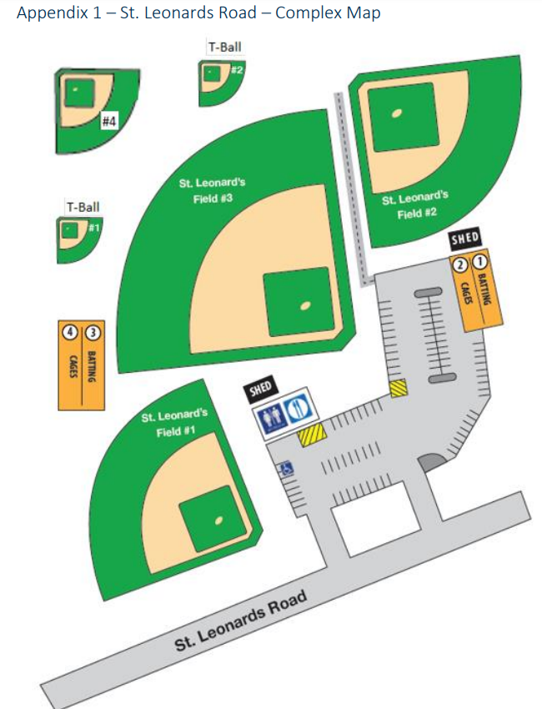

Appendix 2 – Big Meadow – Complex Map
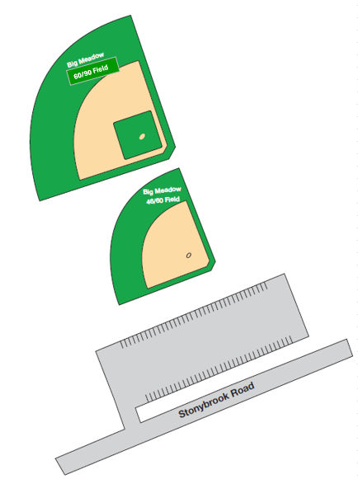

Appendix 3 – Injury Report Form

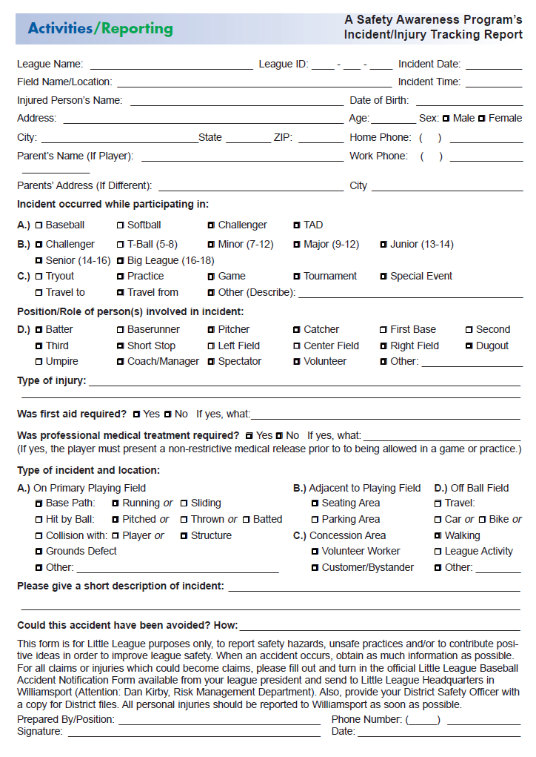

Appendix 4 – Medical Release Form
